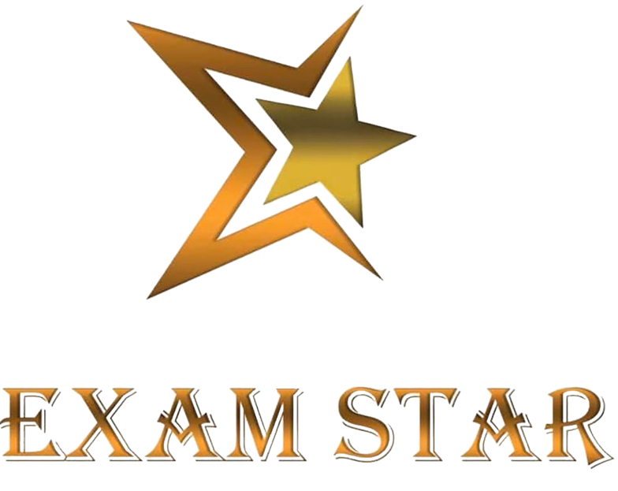

PARENTAL CONSENT AND RESPONSIBILITY AND ACCEPTABLE USE POLICIES

STUDENTS ACCEPTABLE USE POLICY AGREEMENT

THIS IS HOW WE STAY SAFE WHEN WE USE THE EXAM STAR® WEBSITE:

- I will ask my parent/guardian before I log on to the Exam Star® website and learning platform.

- I will only communicate with online tutors using the Exam Star® website and learning platform.

- I understand that for my safety and security, all communication with online tutors outside the Exam Star® website and its learning platform
are strictly forbidden.

- When I log on to the Exam Star® website, and its learning platform I will use my own login, which I will keep secret.

- I will only speak with an online tutor that my parent/guardian has told or allowed me to interact with.

- I will only speak to people I know, or my parent/guardian has approved, and my communication will be polite and sensible.

- When communicating online, I will not give out my home address, phone number, or arrange to meet anyone.

- I will ask for help from my parent/guardian if I am not sure what to do or if I think I have done something wrong.

- If I see or hear anything that I am unhappy with or I receive messages I do not like, I will turn off the screen and tell my parent/guardian immediately.

- I understand that if I deliberately break these rules, I could be stopped from receiving further online tuition provided by Exam Star®.

PARENTS /GUARDIANS CONSENT AND ACCEPTABLE USE POLICY AGREEMENT

By booking a session I confirm that I give consent to my child using the Exam Star® online tutoring services. I also confirm that I have read and agree to abide by the terms of the Exam Star® acceptable use policy agreement.

ACCEPTABLE USE POLICY AGREEMENT

- As the parent /guardian of the above student(s), I give permission for my child/children to have access to the Exam Star® website online learning platform.

- I will only communicate with online tutors using the Exam Star® website and learning platform.

- I understand that for my safety and security, all communication with online tutors outside the Exam Star® website and its learning platform
are strictly forbidden.

- I also understand that Exam Star® cannot ultimately be held responsible for the nature and content of materials accessed on the internet and using mobile technologies.

- I understand that my child’s/children’s activity on the Exam Star® website and online learning platform will be monitored and that Exam Star® will contact me if they have concerns about any possible breaches of the Acceptable Use Policy.

- I will encourage my child to adopt safe use of the internet and digital technologies at home and will inform Exam Star® if I have concerns over my child’s online safety.

- I understand that I am not expected to post pictures of students other than my own children on social networking sites.

- I know that I should make complaints through official Exam Star® channels rather than posting them on social networking sites.

- I will not post malicious or fictitious comments on social networking sites about any member of the Exam Star® community.

- I understand that I should not post comments that would be considered to be unprofessional or reflect Exam Star® or its members in a negative manner.

